STUDY SET 11

WORKING DRAWINGS AND ASSEMBLIES

PROBLEMS FOR LABORATORY WORK

11.1 Assembly Exercise 11.1
Construct 3D models of the two parts of the stand and support given in the projections with the two parts assembled together.
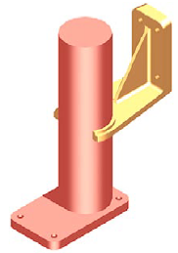

11.2 Classic Problem 11.1 – Sliding Door Guide
- Sketch orthographic views of each part, with dimensions.
- If dimensions are missing, determine what they should be by their relationship to other parts.
- Determine tolerances as noted or assigned.
- Create 3-D models of each part, then extract orthographic views.
- Determine finished surfaces and mark them on the sketch.
- Create dimensioned detail drawings of each non-standard part in the assembly.
- Create an orhthographic or exploded pictorial assembly drawing in section.
- Label all parts in the assembly drawing, using numbers and balloons.
- Create an ANSI standard parts list with all relavent information for the parts in the assembly.

SELECTEDPROBLEMS

11.1 Classic Problem 11.2 – Bell Roller Support
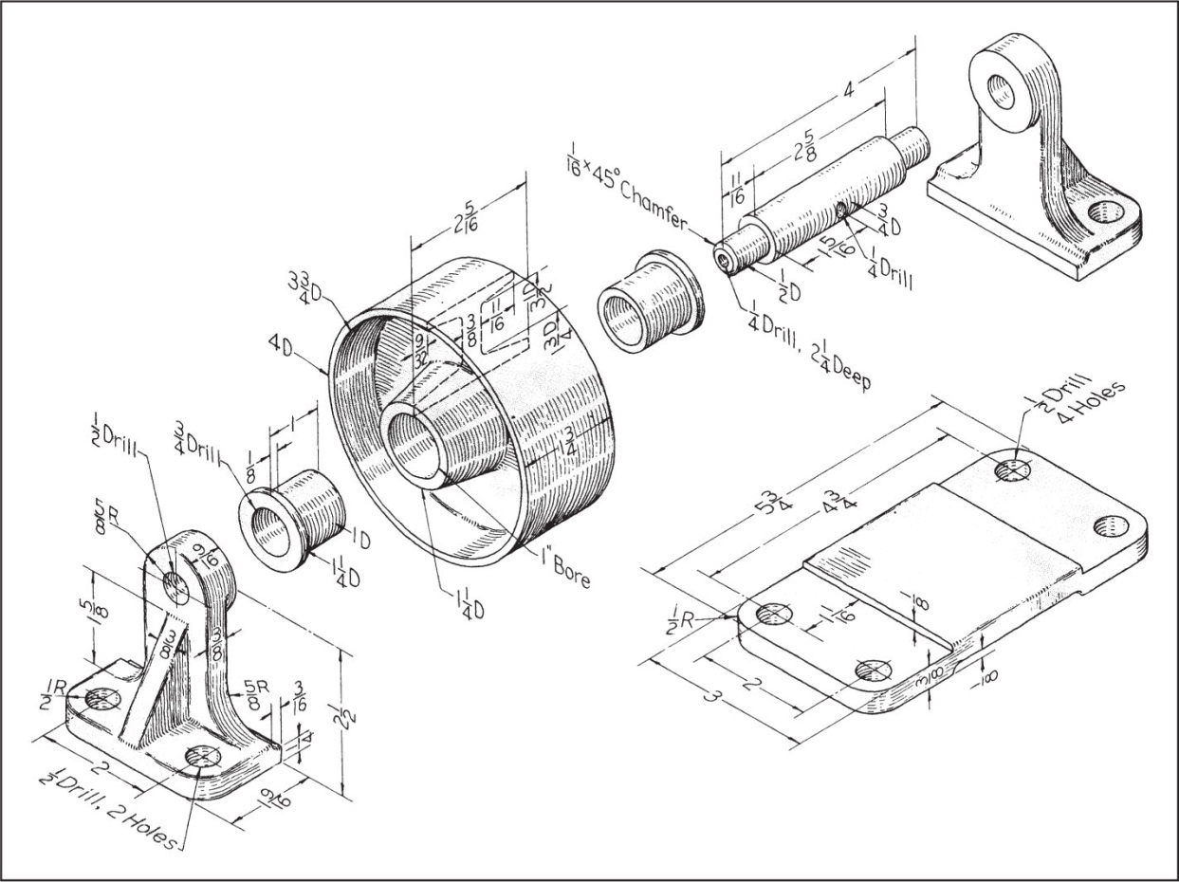

11.2 Classic Problem 11.3 – Anti-vibration Mount
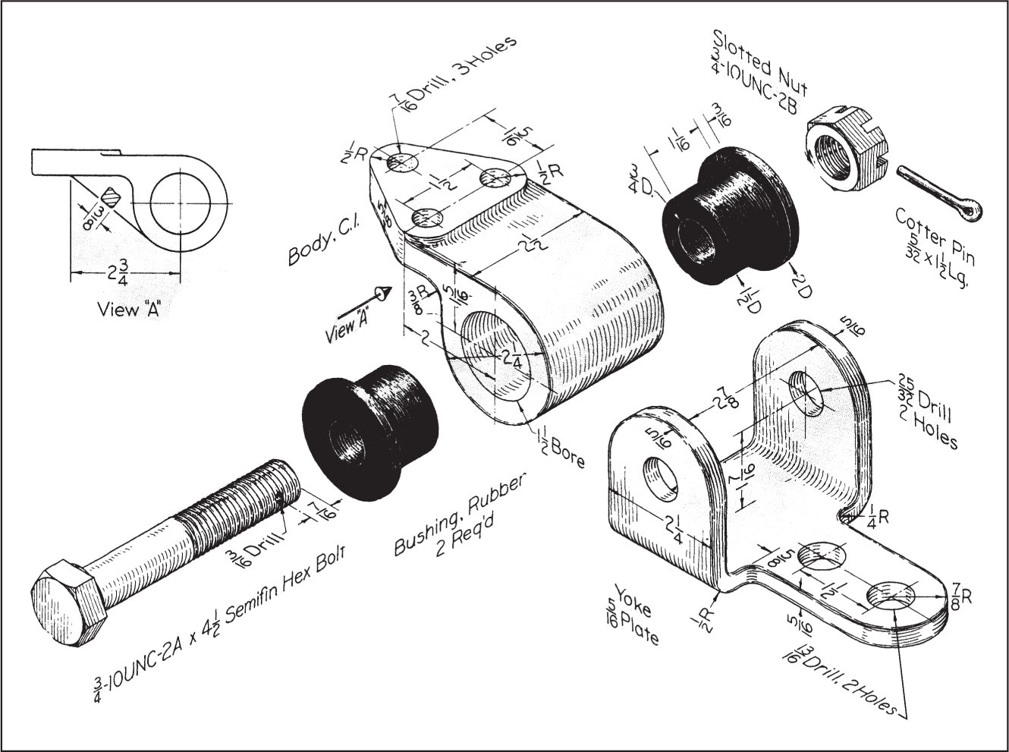
Note- Do not consider threads. Treat them as untreaded rods or holes.

11.3 Classic Problem 11.4 – Pivot Hanger
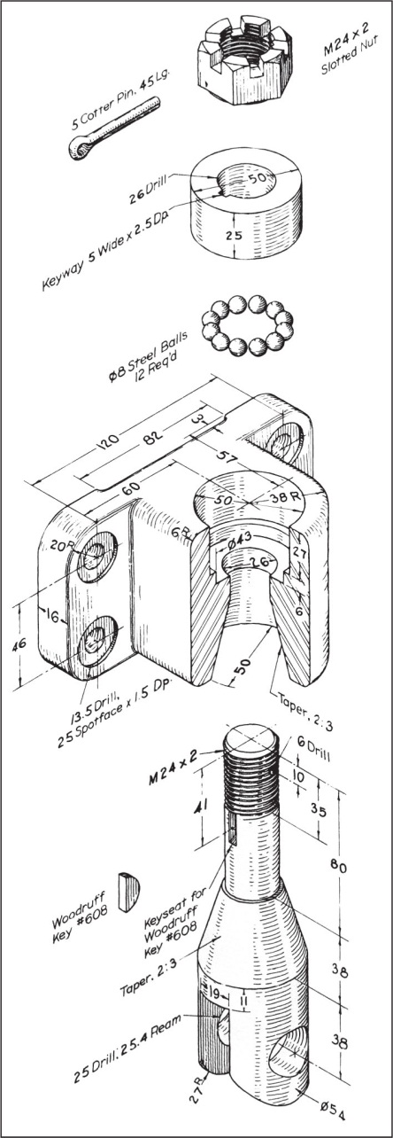Note- Do not consider threads. Treat them as untreaded rods or holes.

11.4 Figure 11.66 - Quick-Acting Hold-Down Clamp
