STUDY SET 09

DIMENSIONING & TOLERANCING PRACTICES

PROBLEMS FOR LABORATORY WORK

9.1 Problem 9.1 (Figure 9.78 (2))
Draw the multiviews using CAD, and then fully dimension the objects.

9.2 Problem 9.1 (Figure 9.78 (4))
Draw the multiviews using CAD, and then fully dimension the objects.

9.3 Problem 9.1 (Figure 9.79 (1))
Draw the multiviews using CAD, and then fully dimension the objects.

9.4 Problem 9.2 (Figure 9.80) – Gusseted Angle Bracket
Sketch, or draw with CAD, a multiview drawing, then add dimensions.
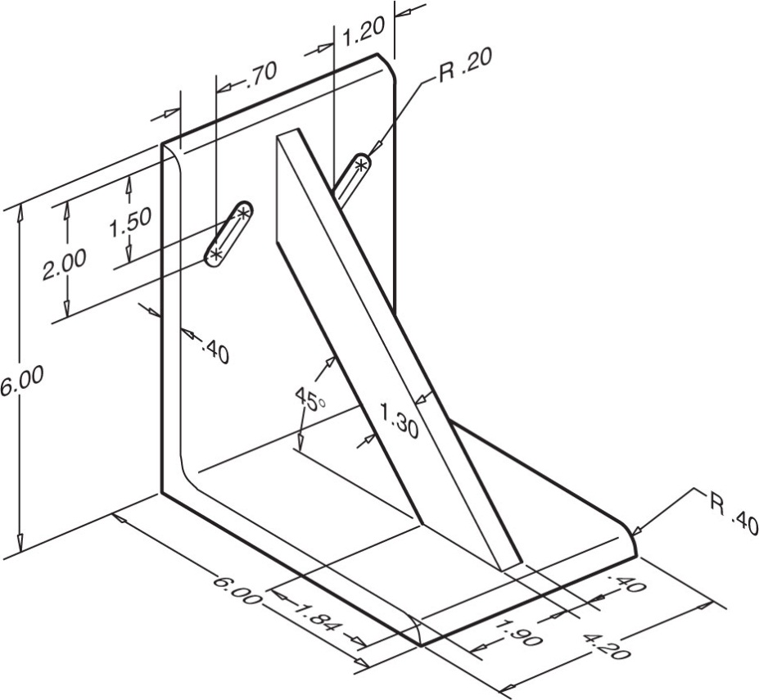

9.5 Problem 9.2 (Figure 9.83) – Foot Mounting
Sketch, or draw with CAD, a multiview drawing, then add dimensions.
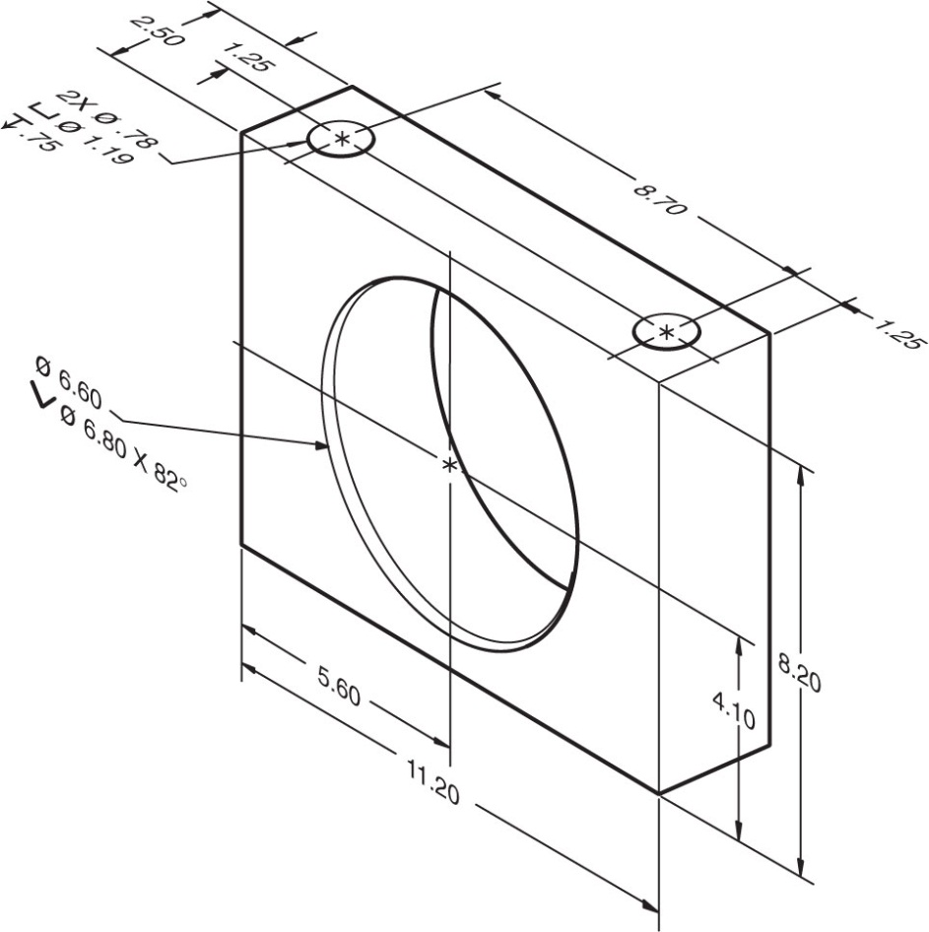

9.6 Problem 9.3 (Figure 9.92) – Shaft and Hole
Using tolerancing tables in appendices, calculate the limit dimensions between the shaft and hole . For the given classes of fit.
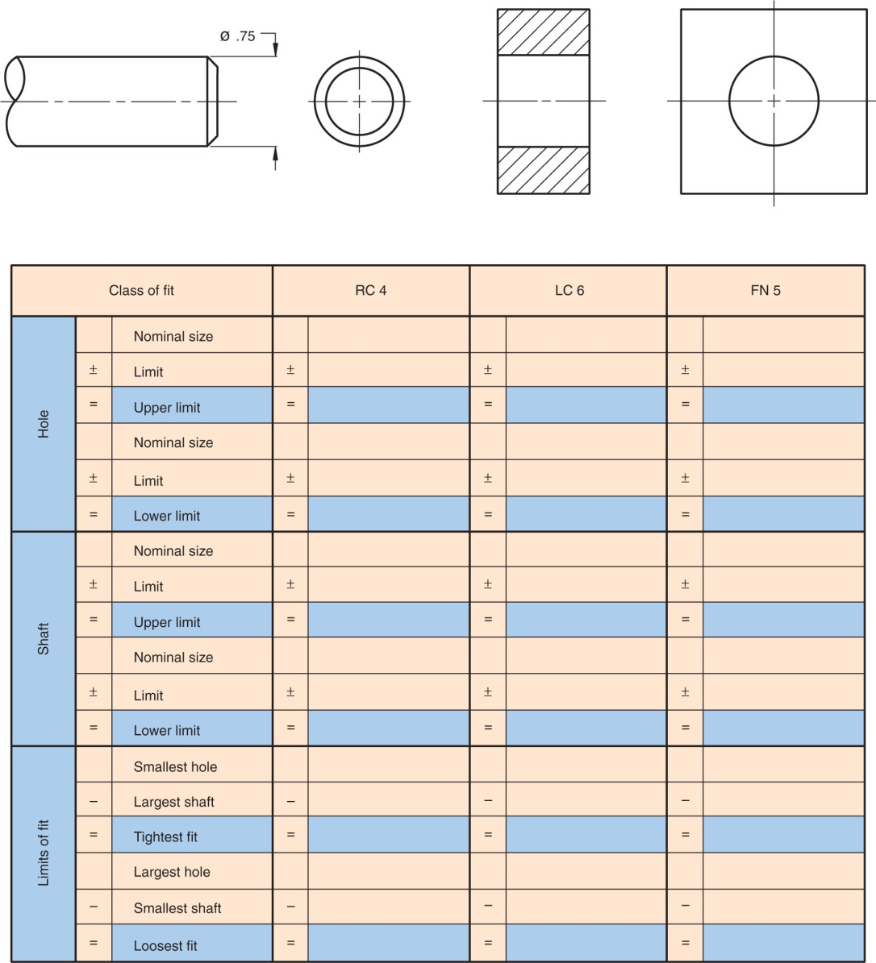

SELECTEDPROBLEMS

9.1 Problem 9.2 (Figure 9.81) – Angle Clamp
Sketch, or draw with CAD, a multiview drawing, then add dimensions. Omit threads.
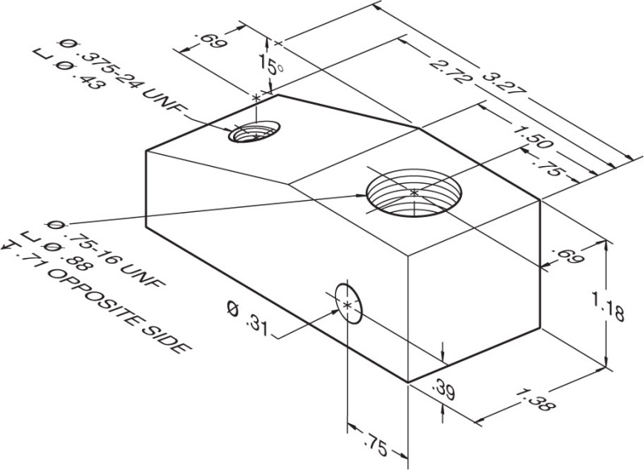

9.2 Problem 9.2 (Figure 9.82) – Clevis Eye
Sketch, or draw with CAD, a multiview drawing, then add dimensions. Omit threads.
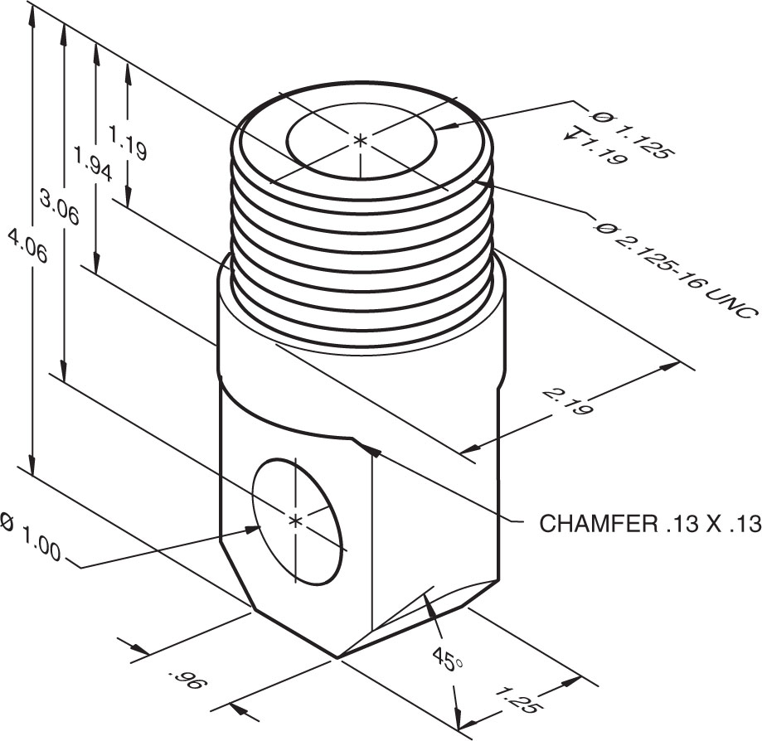

9.3 Problem 9.2 (Figure 9.84) – Flange Mounting
Sketch, or draw with CAD, a multiview drawing, then add dimensions.
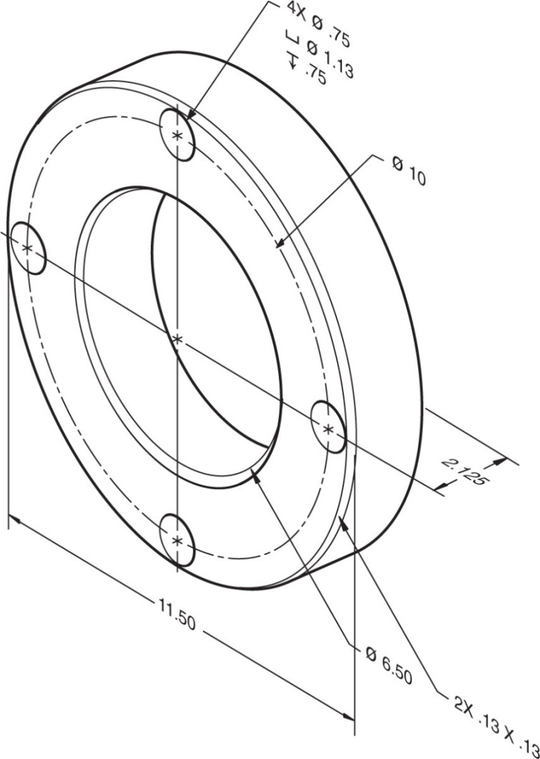

9.4 Problem 9.2 (Figure 9.88) – Standard Bracket
Sketch, or draw with CAD, a multiview drawing, then add dimensions.
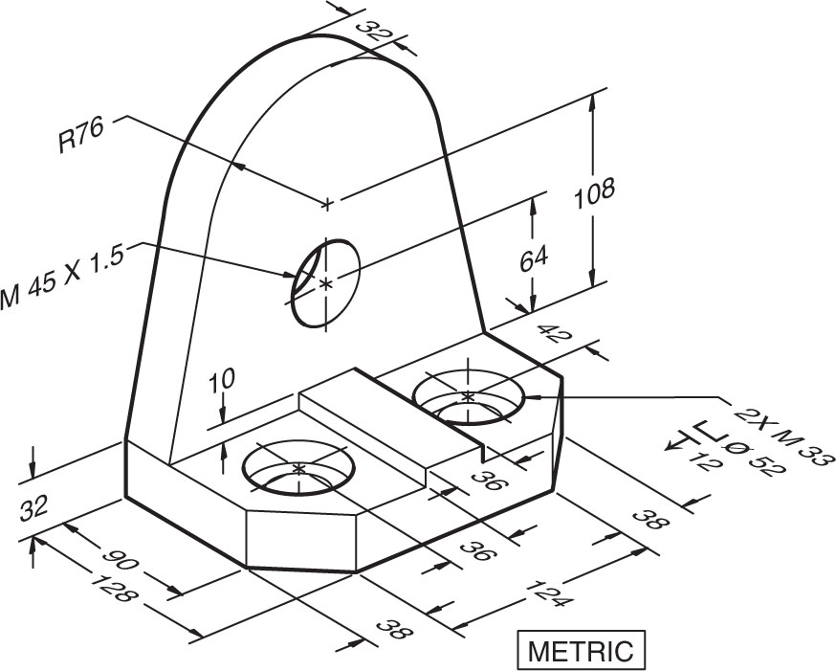

9.5 Problem 9.2 (Figure 9.90) – Gang Mill Fixture Base
Sketch, or draw with CAD, a multiview drawing, then add dimensions.
