STUDY SET 08

SECTION VIEWS

PROBLEMS FOR LABORATORY WORK

8.1 Problem 8.1 (Figure 8.53 (C))
Sketch, or draw with CAD, full-section views. Each grid is 0.25’’ or 10 mm.

8.2 Problem 8.2 (Figure 8.54 (D))
Sketch, or draw with CAD, offset-section views. Each grid is 0.25’’ or 10 mm.

8.3 Problem 8.3 (Figure 8.55 (B))
Sketch, or draw with CAD, half-section views. Each grid is 0.25’’ or 10 mm.

8.4 Problem 8.5 (Figure 8.57 (5))
Sketch, or draw with CAD, the views with sections as indicated by the cutting plane lines. Each grid is 0.25’’ or 10 mm.

8.5 Problem 8.5 (Figure 8.57 (18))
Sketch, or draw with CAD, the views with sections as indicated by the cutting plane lines. Each grid is 0.25’’ or 10 mm.

8.6 Problem 8.6 (Figure 8.59) Counter Block
Sketch, or draw with CAD, then create the necessary views, including a section view, or create a 3-D model.
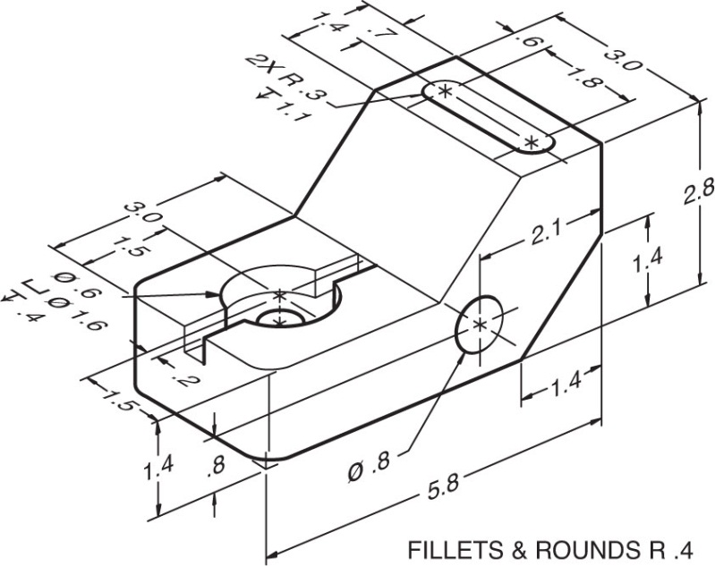

8.7 Problem 8.6 (Figure 8.63) Taper Collar
Sketch, or draw with CAD, then create the necessary views, including a section view, or create a 3-D model.
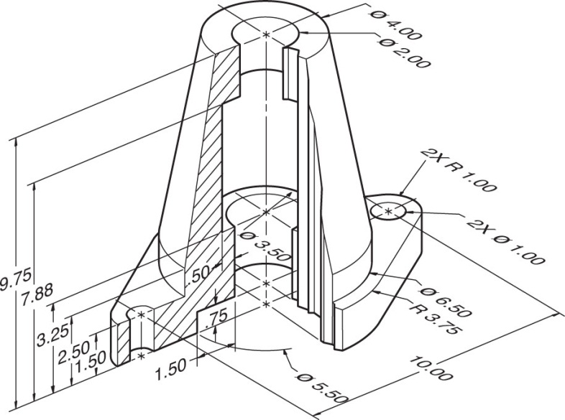

8.8 Problem 8.6 (Figure 8.65) Heavy-Duty V-Pulley
Sketch, or draw with CAD, then create the necessary views, including a section view, or create a 3-D model.
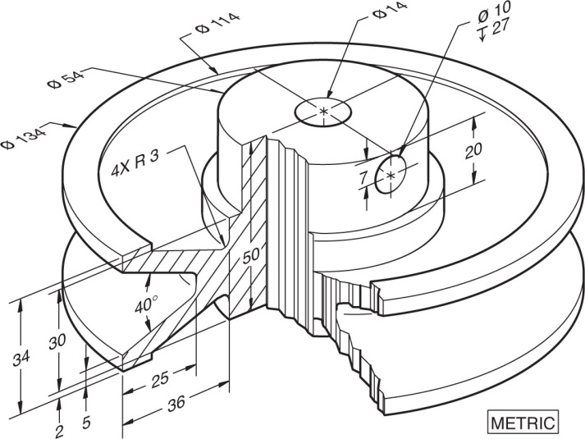

8.9 Classic Problem 1 – End Plate
Select views that will best describe the piece. Draw the multiviews, one of which is sectioned.
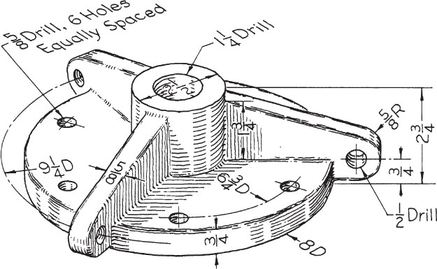

8.10 Figure 8.70 – Roller-Model TX
Construct 3-D solid part, then create the necessary views, including a section view.
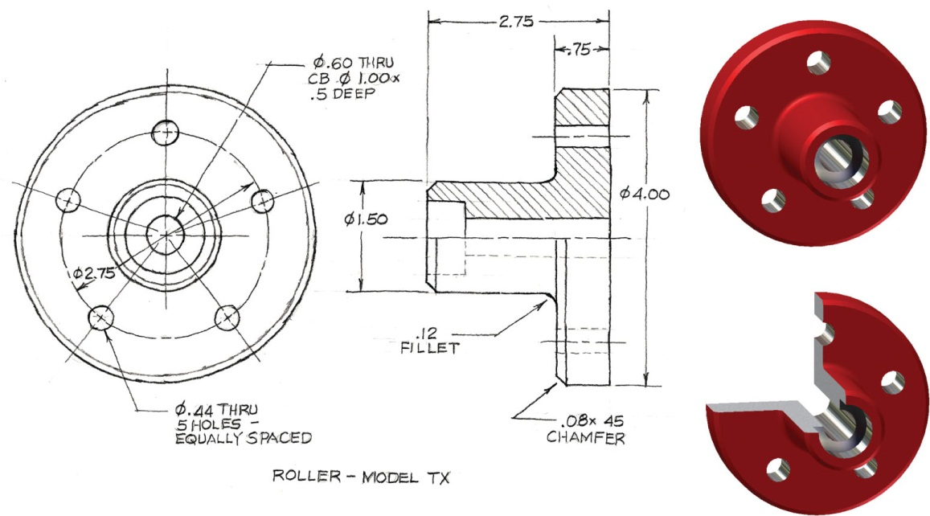

SELECTEDPROBLEMS

8.1 Problem 8.1 (Figure 8.53 (D))
Sketch, or draw with CAD, full-section views. Each grid is 0.25’’ or 10 mm.

8.2 Problem 8.2 (Figure 8.54 (C))
Sketch, or draw with CAD, offset-section views. Each grid is 0.25’’ or 10 mm.

8.3 Problem 8.3 (Figure 8.55 (A))
Sketch, or draw with CAD, offset-section views. Each grid is 0.25’’ or 10 mm.

8.4 Problem 8.5 (Figure 8.57)
Sketch, or draw with CAD, the views with sections as indicated by the cutting plane lines. Each grid is 0.25’’ or 10 mm.
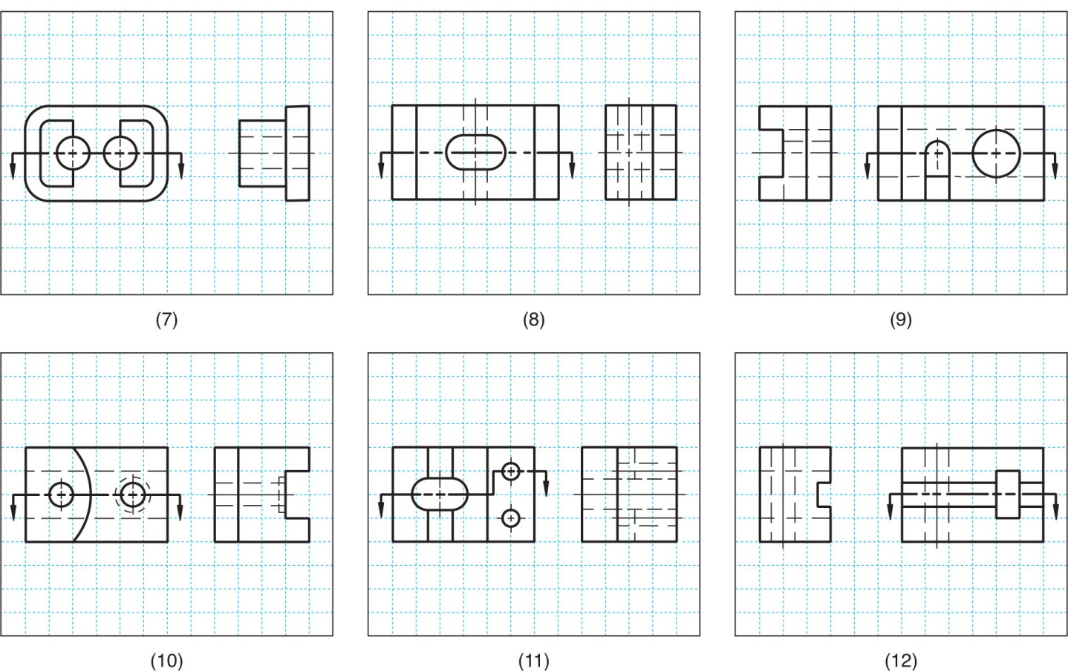
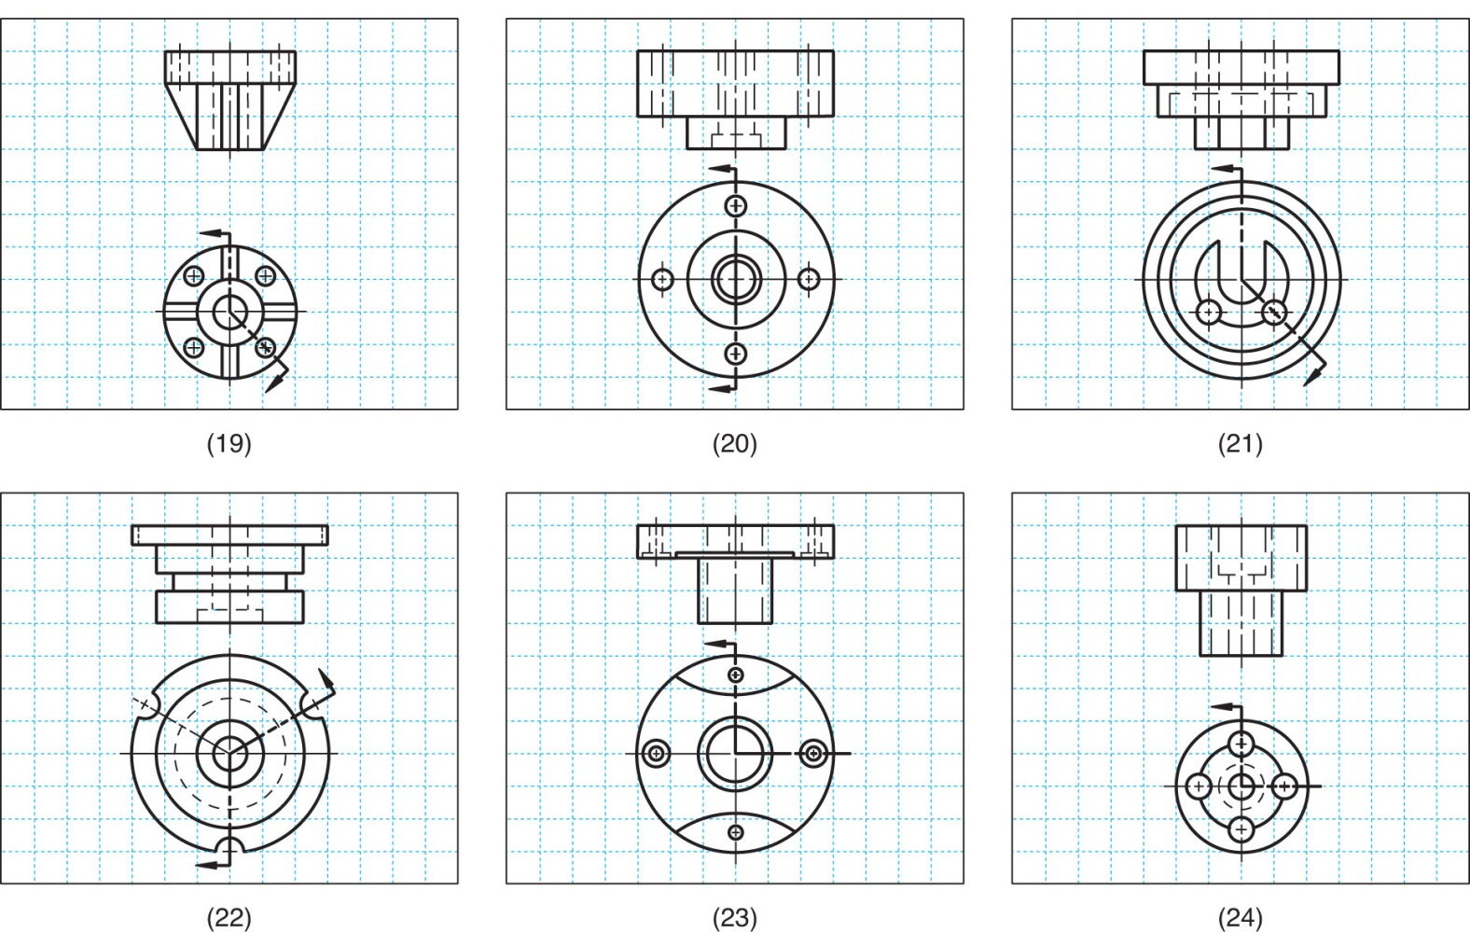

8.5 Figure 8.71 – Shift Link
Construct 3-D solid part, then create the necessary views, including a section view.
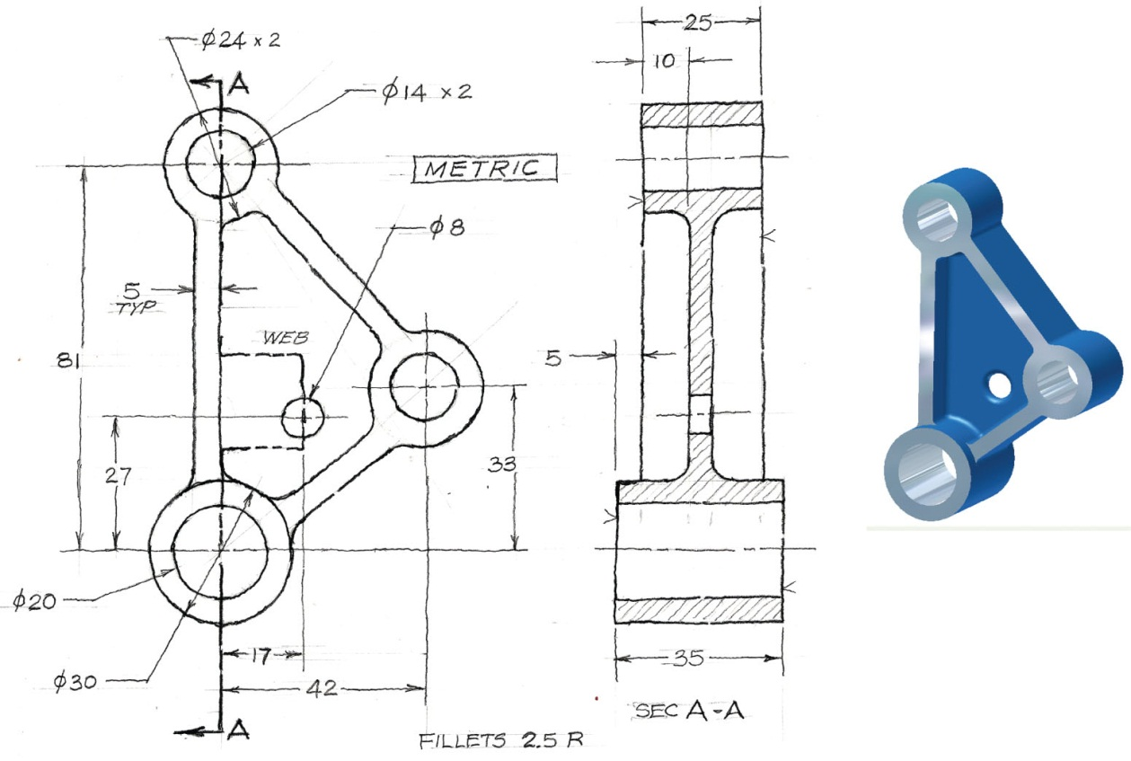

8.6 Figure 8.72 – Hand Wheel
Construct 3-D solid part, then create the necessary views, including a section view.
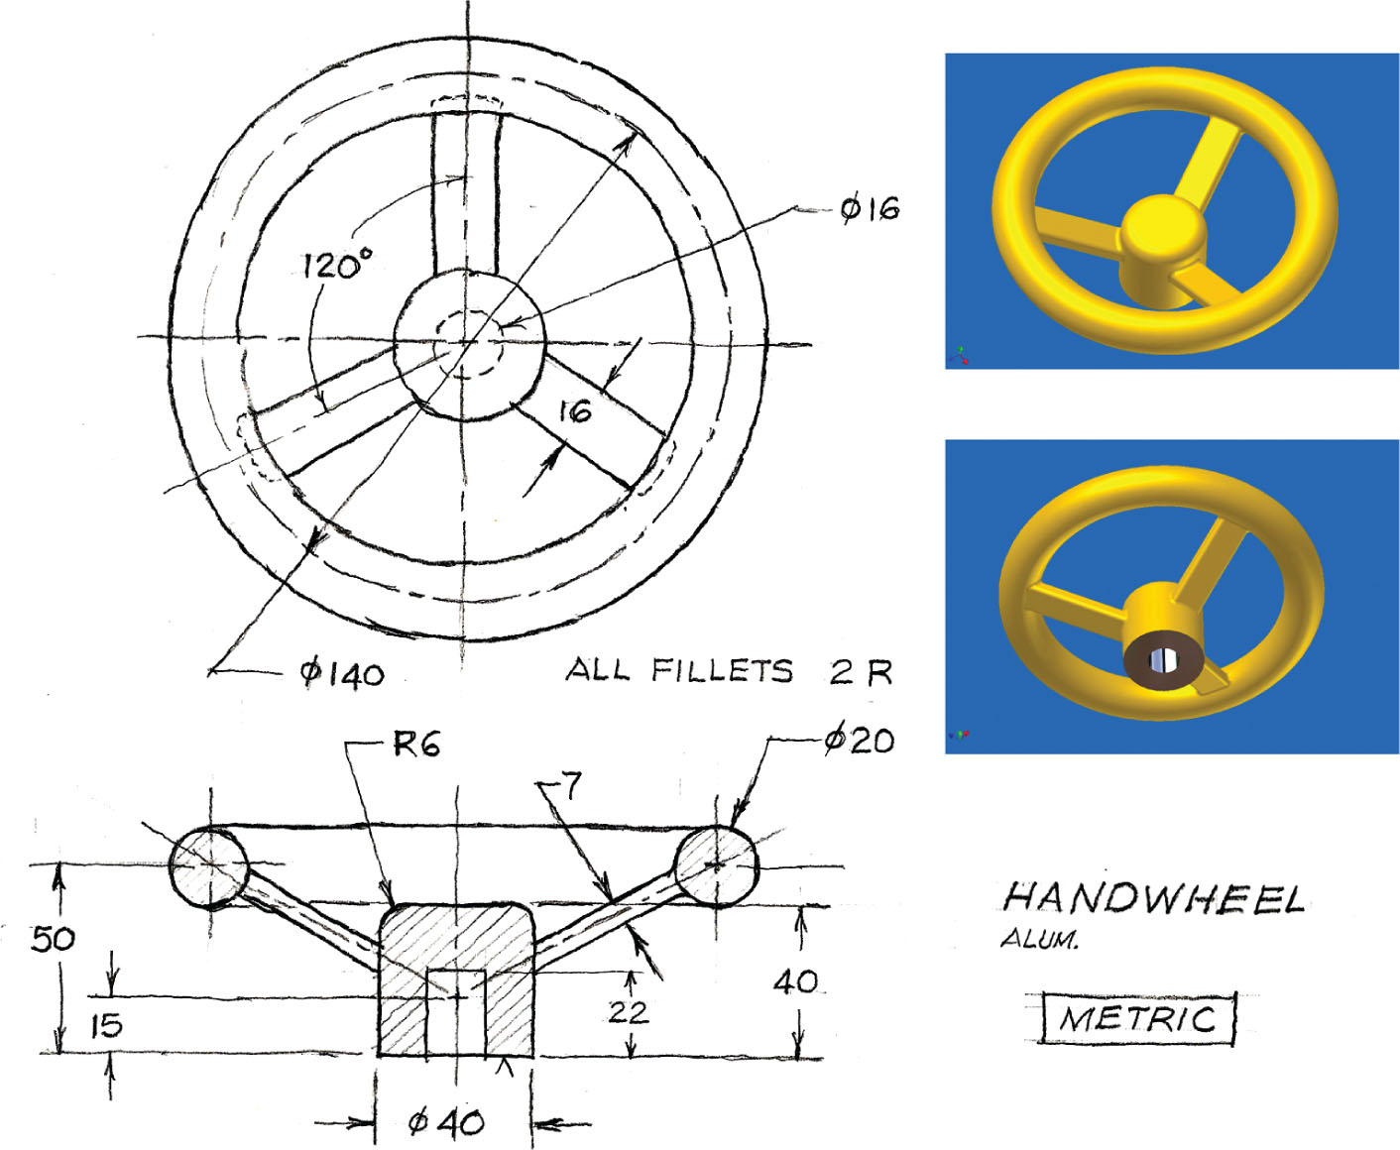

8.7 Figure 8.74 – Ceiling Fan Cover
Construct 3-D solid part, then create the necessary views, including a section view.
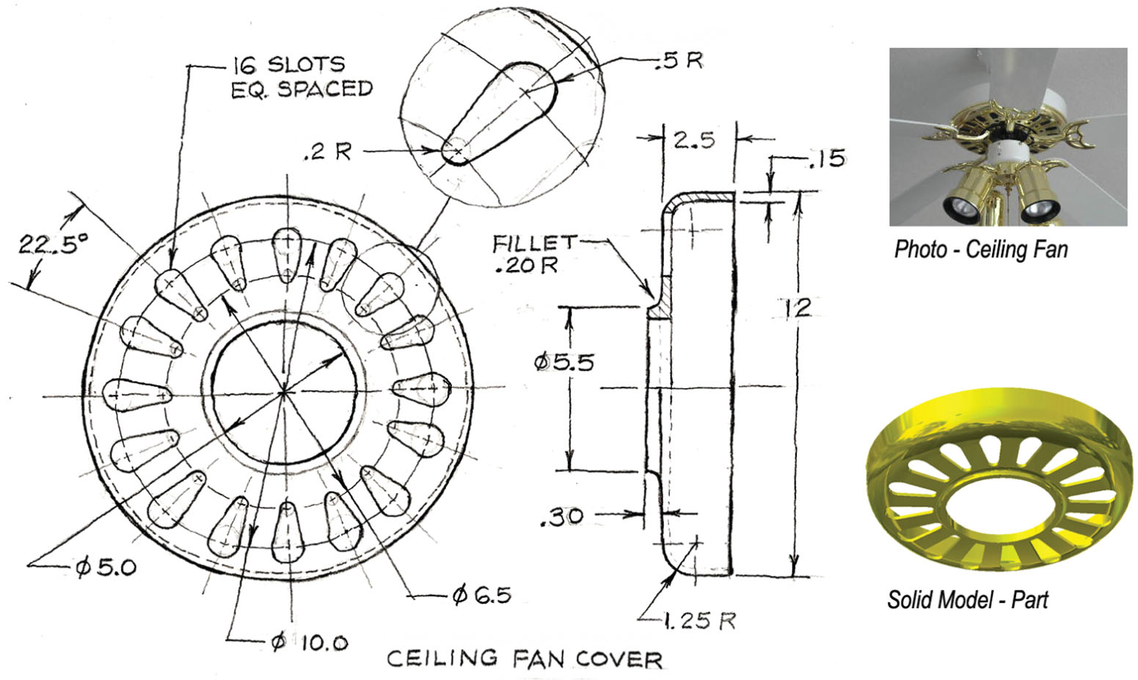

CLASSIC PROBLEMS

8.1 Classic Problem 2 – Piston Cap
Select views that will best describe the piece. Draw the multiviews, one of which is sectioned.
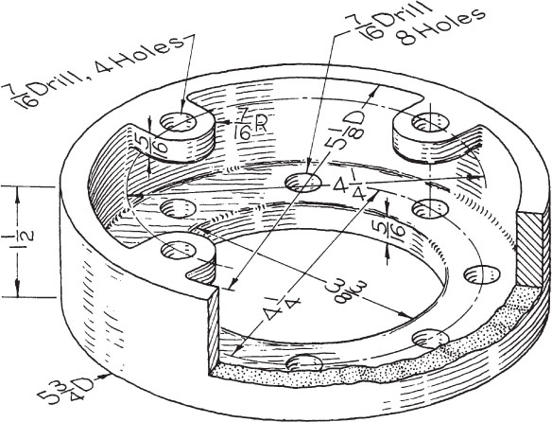

8.2 Classic Problem 4 – Column Collar
Select views that will best describe the piece. Draw the multiviews, one of which is sectioned.
