STUDY SET 07

PICTORIAL PROJECTIONS

PROBLEMS FOR LABORATORY WORK

7.1 Problem 5.5 (Figure 5.122 (18))
Create isometric drawings of the objects directly or through solid drawing.

7.2 Problem 5.5 (Figure 5.122 (90))
Create isometric drawings of the objects directly or through solid drawing.

7.3 Problem 5.5 (Figure 5.122 (93))
Create isometric drawings of the objects directly or through solid drawing.

7.4 Problem 5.7 (Figure 5.130) Motor Plate
Create isometric drawings of the objects directly or through solid drawing.
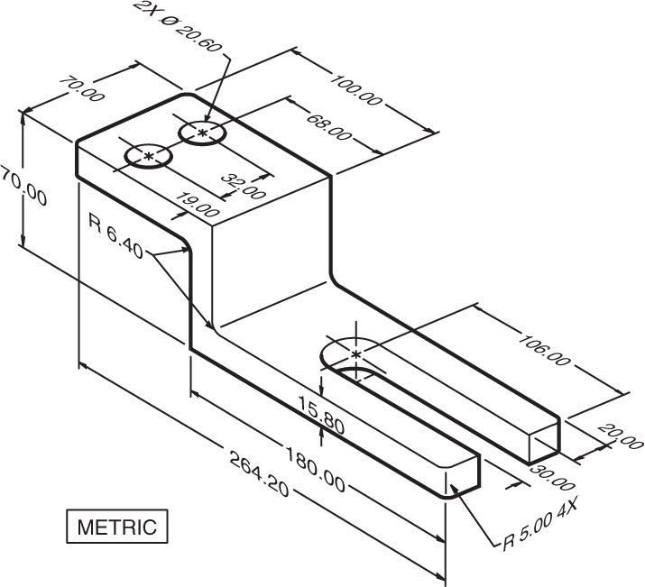

7.5 Problem 5.7 (Figure 5.136) Stop Base
Create isometric drawings of the objects directly or through solid drawing.
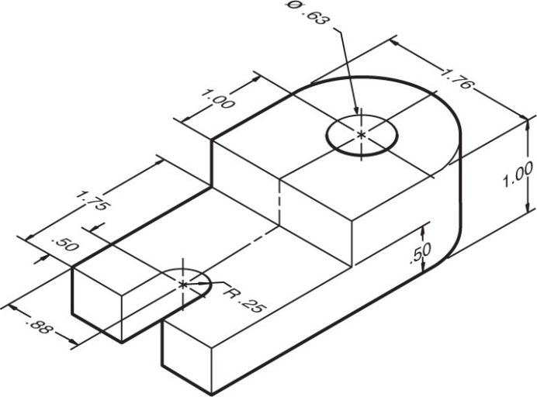

7.6 Problem 5.7 (Figure 5.154) Bearing Block
Create isometric drawings of the objects directly or through solid drawing.
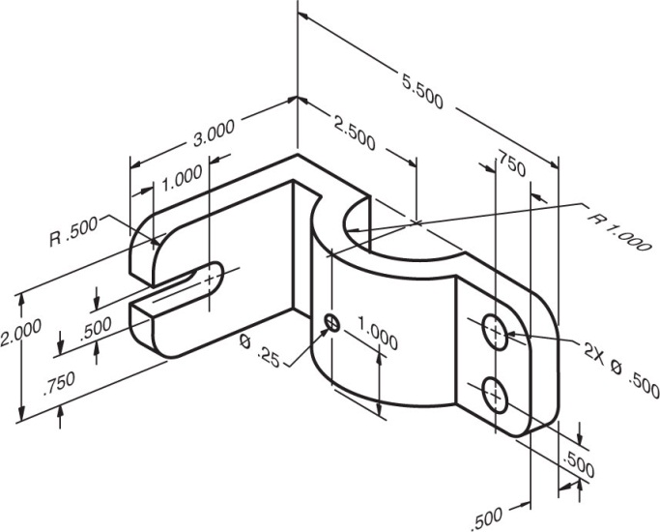

7.7 Problem 6.3 (Figure 6.23) Spindle Base
Create isometric drawings of the objects through solid drawing.
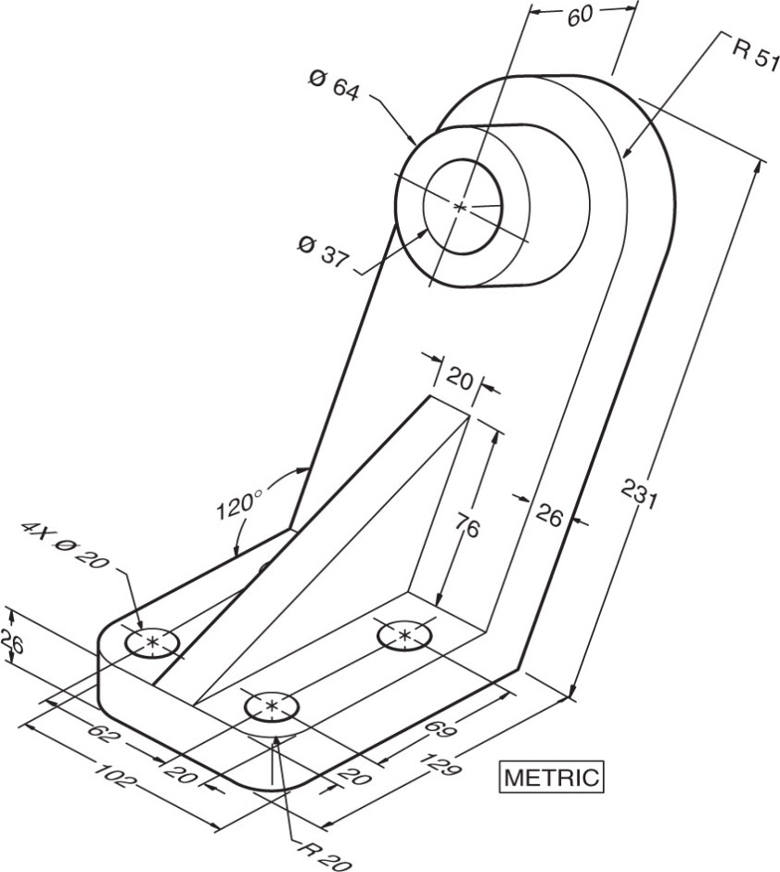

7.8 Problem 6.3 (Figure 6.28) Cylinder Stop
Create isometric drawings of the objects through solid drawing.
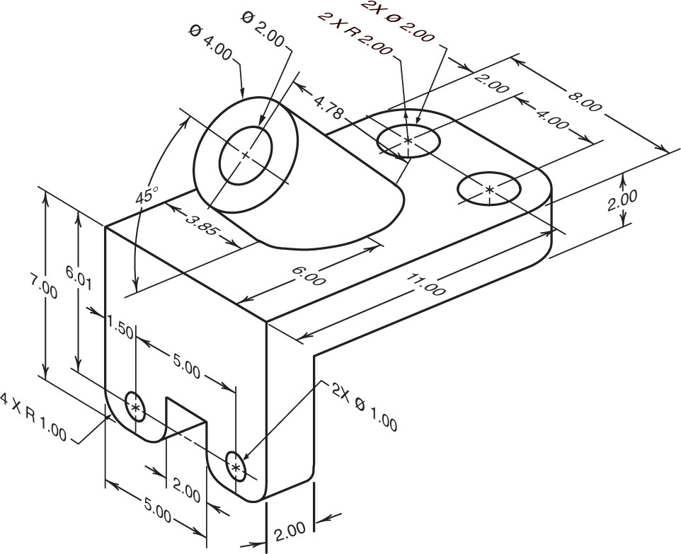

7.9 Practice Problem 7.3
Sketch a one-point perspective of the object on the grid.
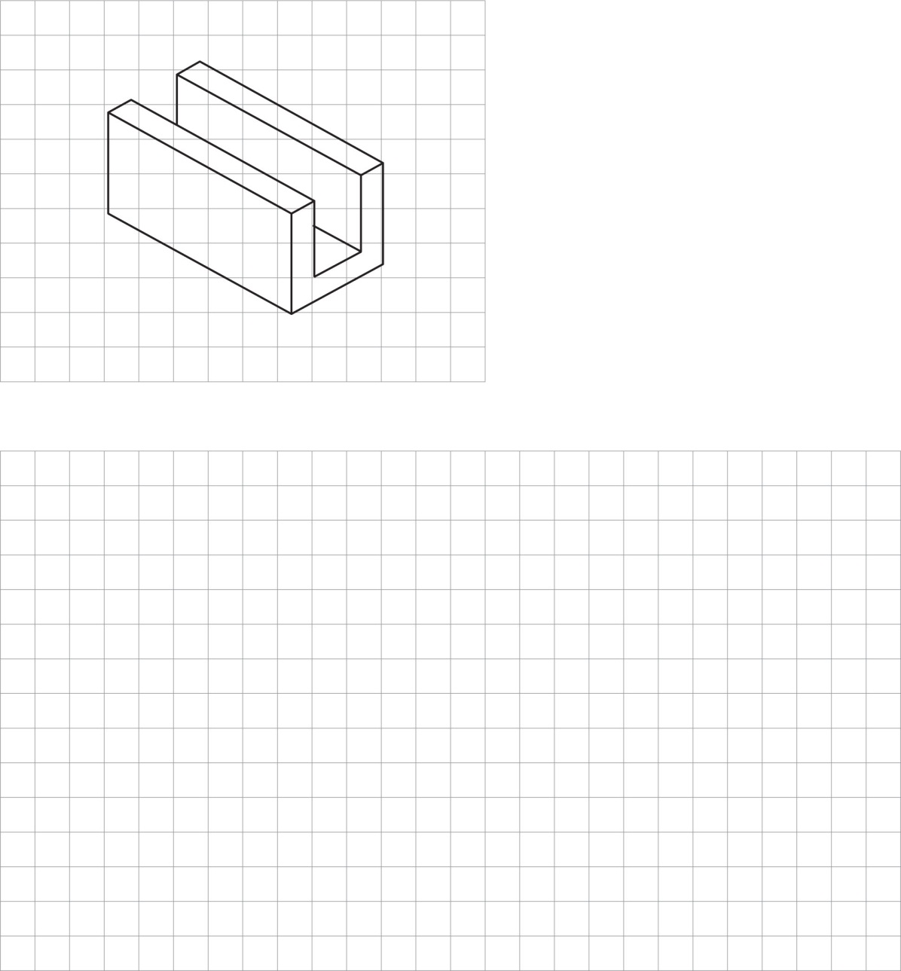

7.10 Problem 7.1 (Figure 7.60 (6))
Construct the isometric view from the multiview.

7.11 Problem 7.1 (Figure 7.60 (8))
Construct the isometric view from the multiview.

7.12 Problem 7.1 (Figure 7.60 (15))
Construct the isometric view from the multiview.

7.13 Problem 7.8 (Figure 7.62)
Create one-point perspective drawing of the object.
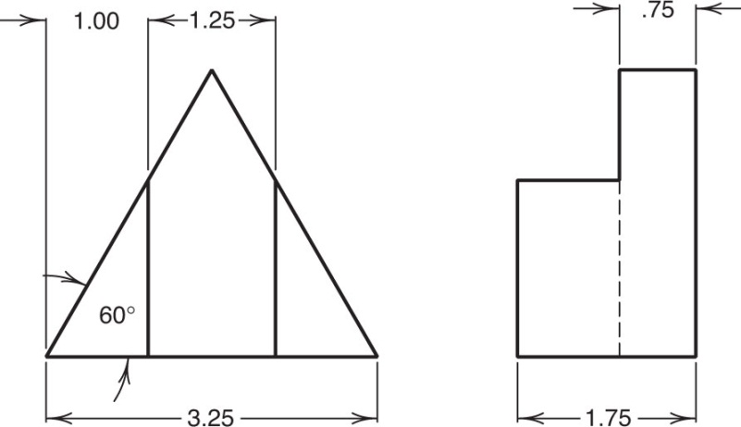

7.14 Classic Problem 3 - Bracket
Create either isometric, oblique, or pictorial drawings of the object.
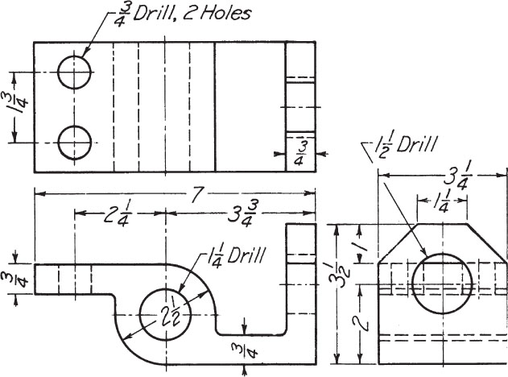

SELECTEDPROBLEMS

7.1 Problem 5.5 (Figure 5.122)
Construct the isometric views of the gridded objects.
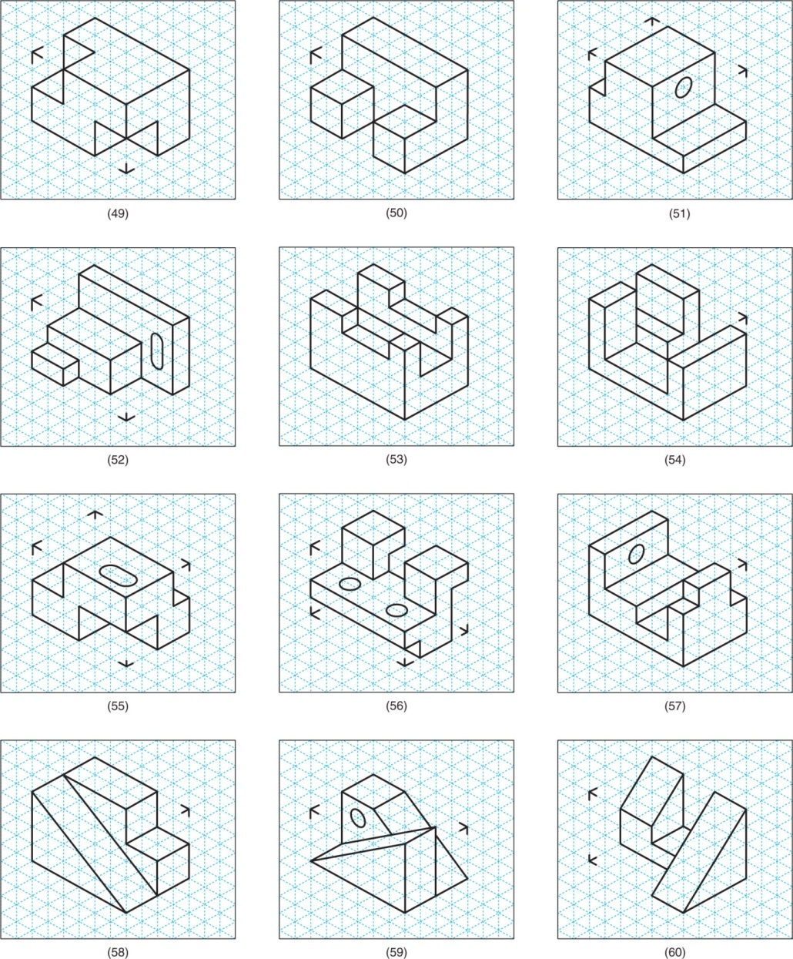

7.2 Problem 5.7 (Figure 5.128) Half Pin
Create isometric drawing of the object directly or through solid drawing.
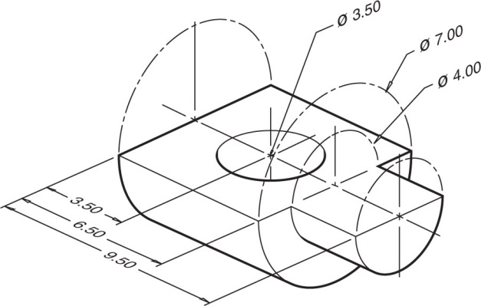

7.3 Problem 5.7 (Figure 5.133) Control Back
Create isometric drawing of the object directly or through solid drawing.
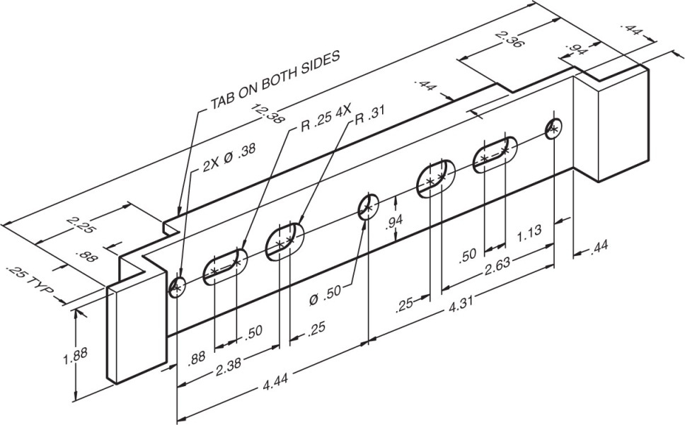

7.4 Problem 5.7 (Figure 5.136) Stop Base
Create isometric drawing of the object directly or through solid drawing.
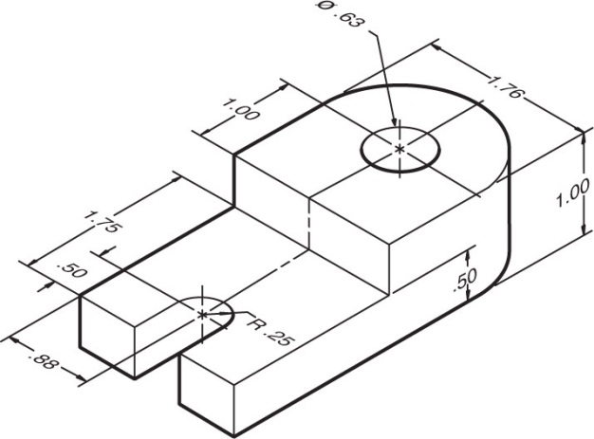

7.5 Problem 5.7 (Figure 5.139) Pen Block
Create isometric drawing of the object directly or through solid drawing.
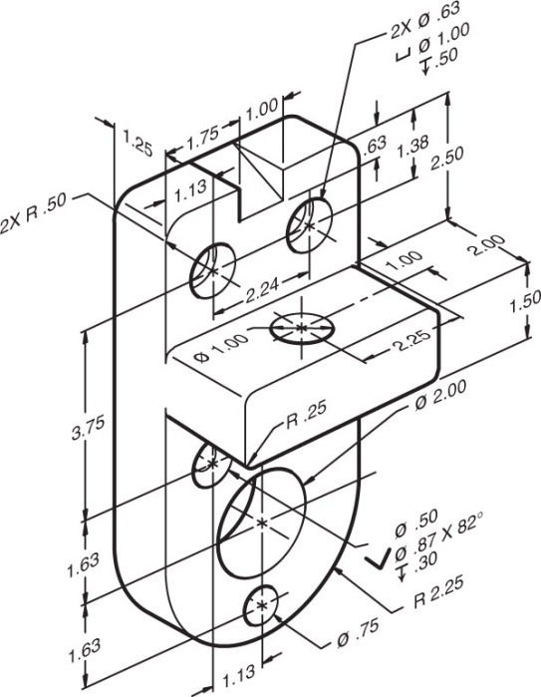

7.6 Problem 7.1 (Figure 7.60)
Construct the isometric views from the multiviews.

7.7 Problem 7.8 (Figure 7.61)
Create one-point perspective drawing of the object.
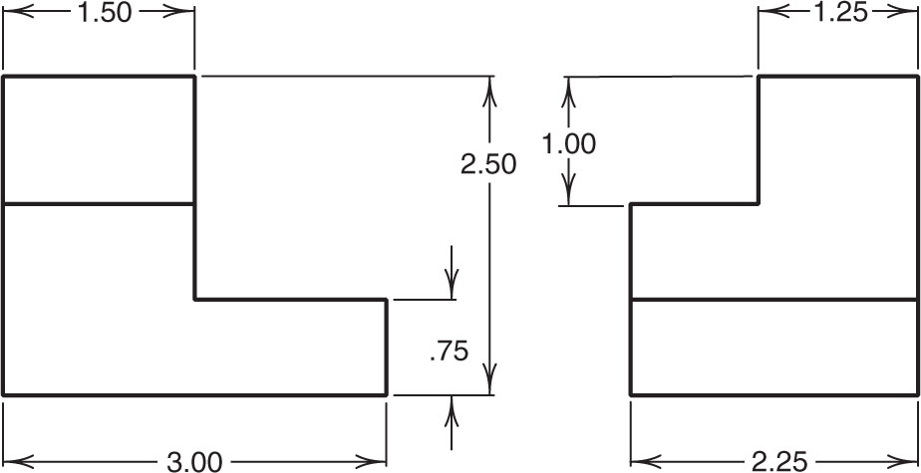

7.8 Problem 7.8 (Figure 7.63)
Create one-point perspective drawing of the object.
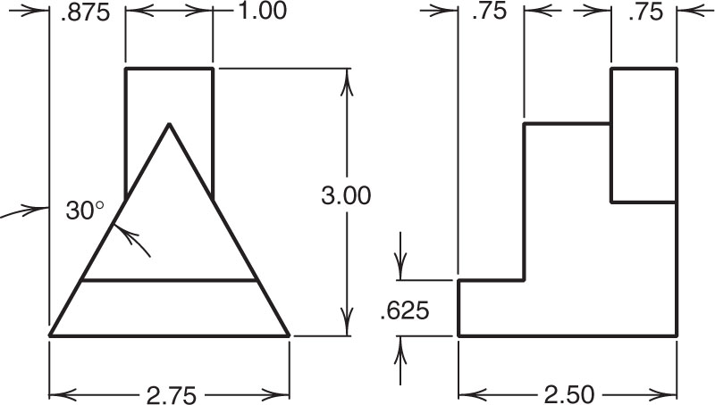

CLASSIC PROBLEMS

7.1 Classic Problem 4 – Hinged Catch
Create either isometric, oblique, or pictorial drawings of the object.
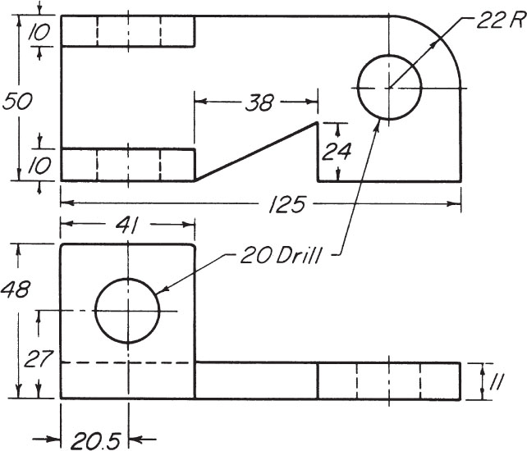

7.2 Classic Problem 5 – Offset Bracket
Create either isometric, oblique, or pictorial drawings of the object.
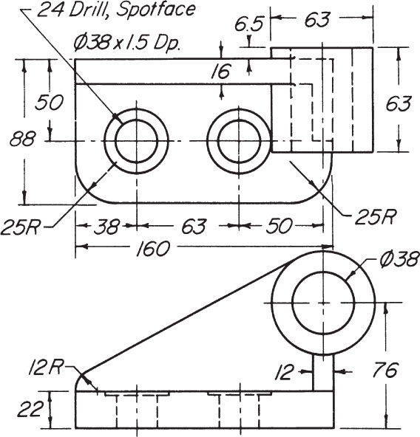

7.3 Classic Problem 6 – Cross-Link
Create either isometric, oblique, or pictorial drawings of the object.
