STUDY SET 06

AUXILIARY VIEWS

PROBLEMS FOR LABORATORY WORK

6.1 Problem 6.1 (Figure 6.17 (5))
Using instruments or CAD, sketch or draw the two given views and a partial auxiliary view of the inclined surface.

6.2 Problem 6.2 (Figure 6.18 (19))
Using instruments or CAD,sketch or draw the two given views and a complete or a partial auxiliary view of the inclined surfaces.

6.3 Problem 6.3 (Figure 6.23) Spindle Base
Using instruments or CAD, sketch or draw the necessary views, including a complete auxiliary view.
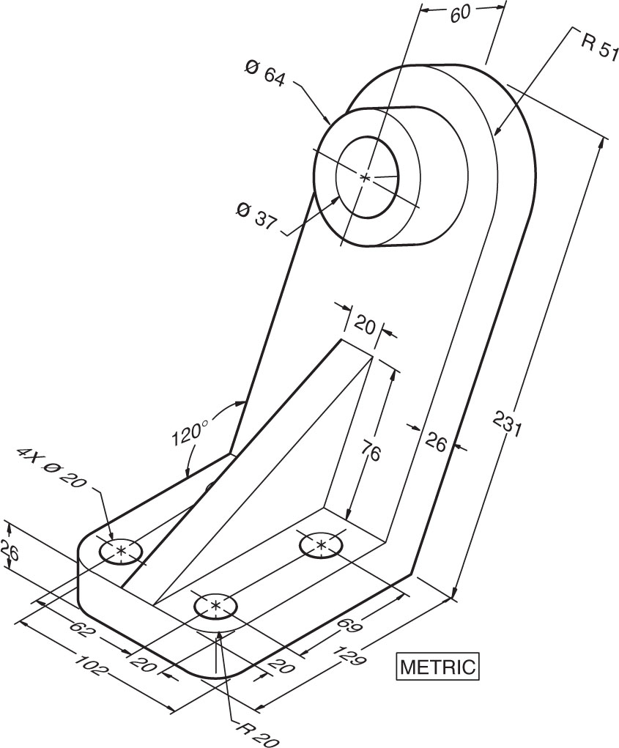

SELECTEDPROBLEMS

6.1 Problem 6.1 (Figure 6.17)
Using instruments or CAD,sketch or draw the two given views and a partial auxiliary view of the inclined surfaces.
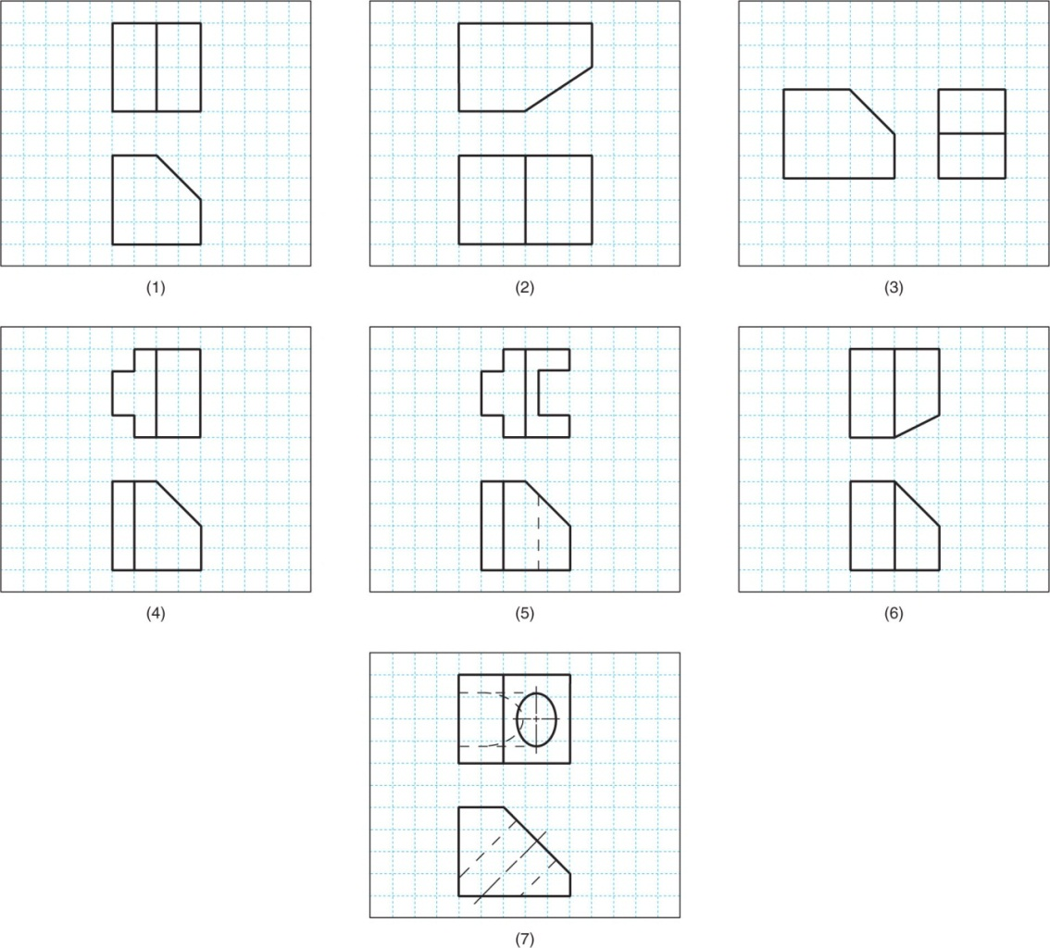

6.2 Problem 6.2 (Figure 6.18)
Using instruments or CAD,sketch or draw the two given views and a complete or a partial auxiliary view of the inclined surfaces.
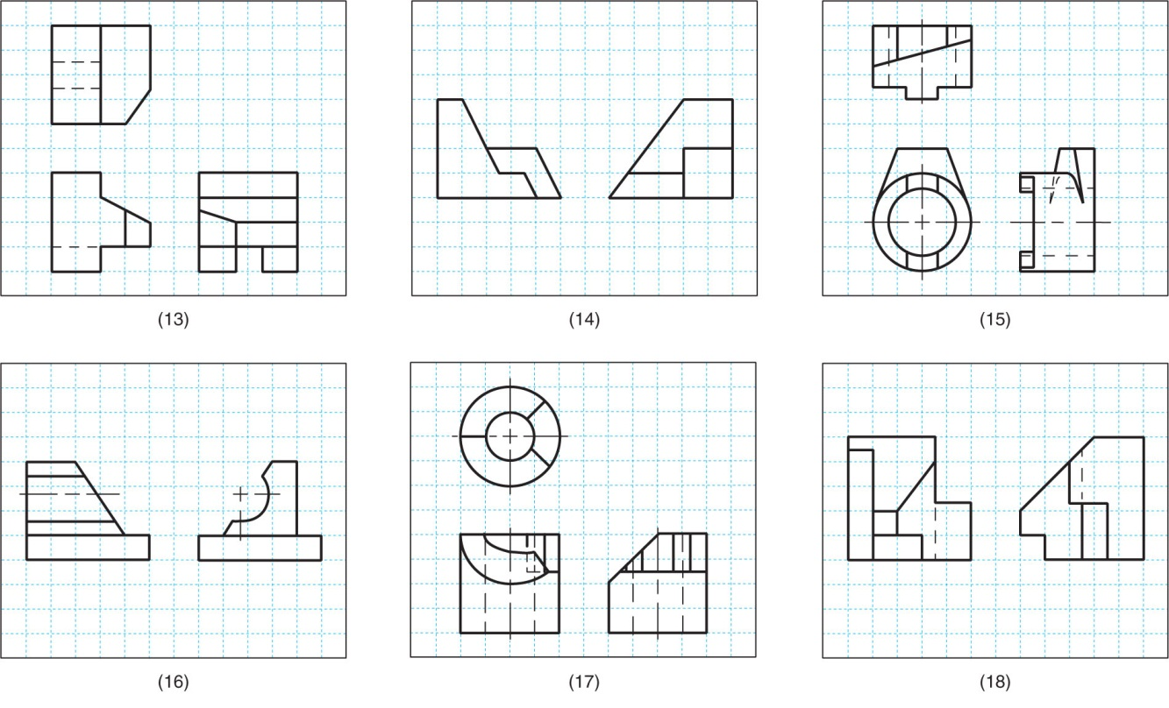

6.3 Problem 6.3 (Figure 6.19) Rod Support
Using instruments or CAD,sketch or draw the necessary views, including a complete auxiliary view.
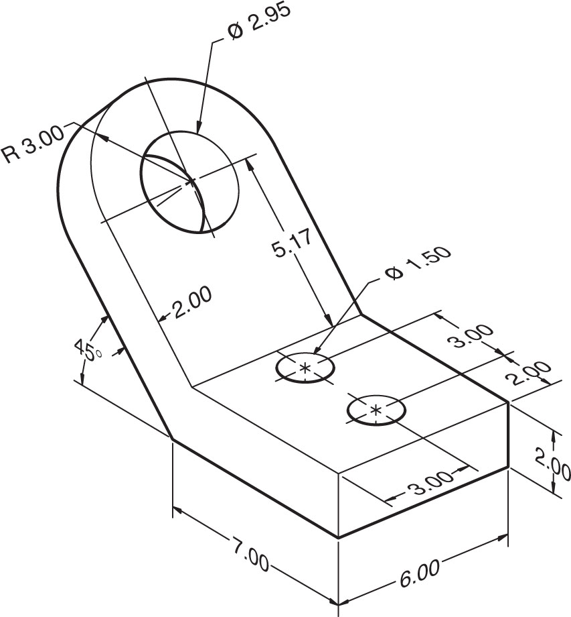

6.4 Problem 6.3 (Figure 6.20) Automatic Stop
Using instruments or CAD,sketch or draw the necessary views, including a complete auxiliary view.
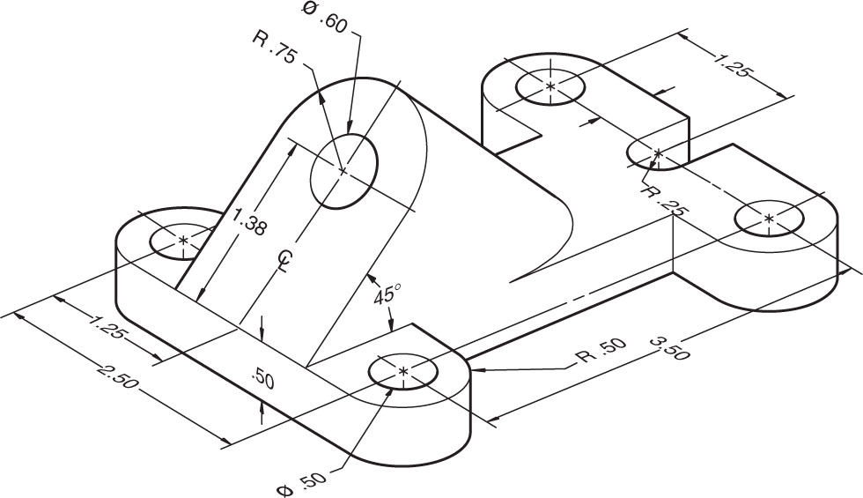

6.5 Problem 6.3 (Figure 6.26) Fixture Base
Using instruments or CAD,sketch or draw the necessary views, including a complete auxiliary view.
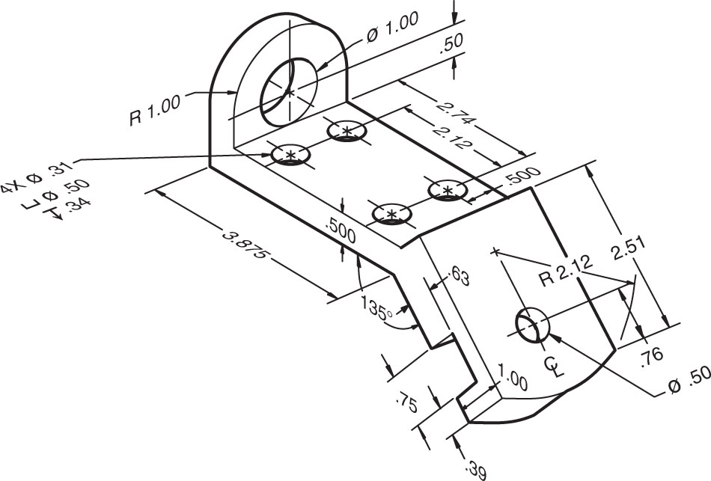

6.6 Problem 6.3 (Figure 6.28) Cylinder Stop
Using instruments or CAD,sketch or draw the necessary views, including a complete auxiliary view.
