STUDY SET 04

MODELING FUNDAMENTALS

PROBLEMS FOR LABORATORY WORK

4.1 Circular Sweep
Sketch the resulting solid model if the given profiles were to be circularly swept 360 degrees about the Y axis.
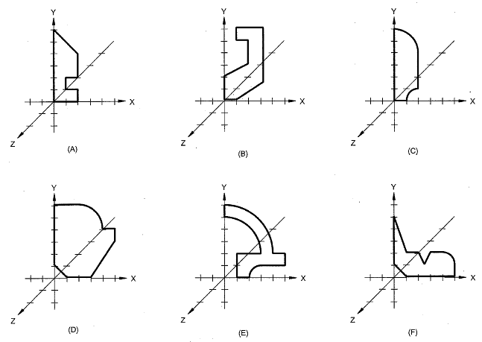

4.2 Linear Sweep
Sketch the resulting solid model if the given profiles were to be linearly swept 2 units along the +Z axis.

4.3 Boolean Operations
Given the three overlapping solid primitives, make an isometric sketch of the resulting solid after applying the following Boolean operations: A-B-C.
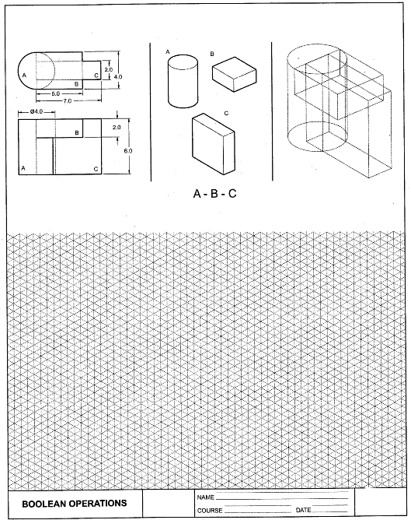

4.4 Problem 4.6 (Figure 4.51)
Create the objects using solid modeling techniques. Use grid snap.
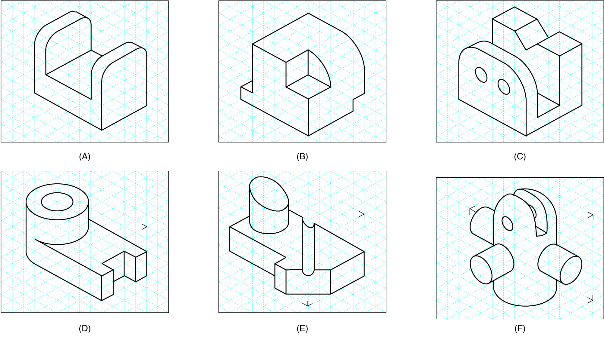

4.5 Solid Exercise 1
Create the objects given below using the top view dimensions.
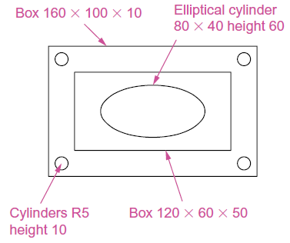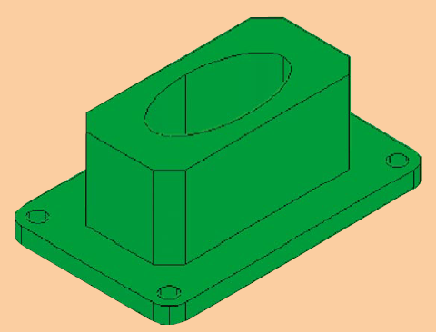

4.6 Solid Exercise 3
Create the objects given below using the top view dimensions.
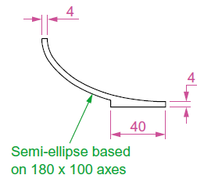

4.7 Solid Exercise 4
Create the objects given below using the top view dimensions and the directrix.
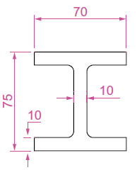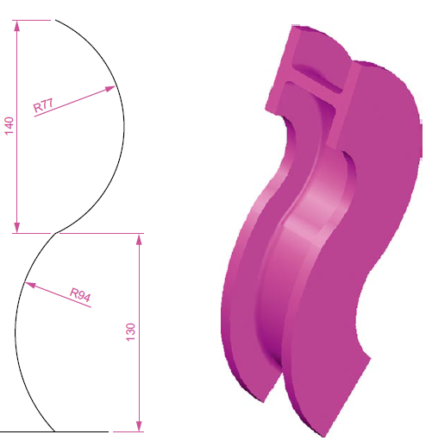

4.8 Solid Exercise 5
Create the objects given below using loft tool.
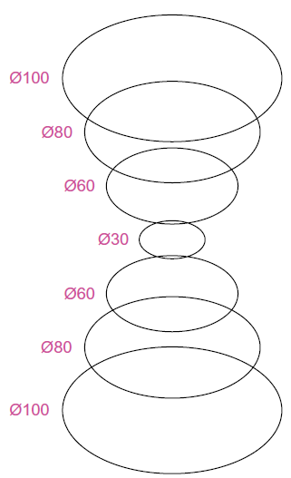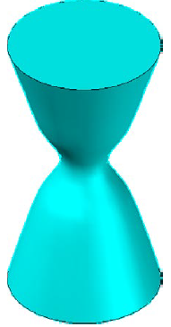

4.9 Solid Exercise 6
Working to the dimensions given, construct an extrusion of the plate to a height of 40 units.
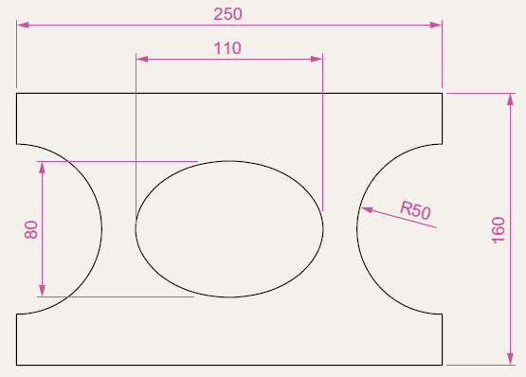

4.10 Solid Exercise 7
Working to the polylines given, construct the Sweep shown below.
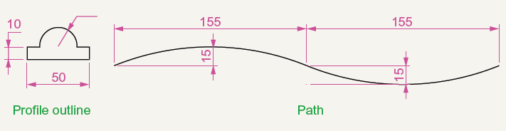

4.11 Solid Exercise 9
Construct the solid model shown below.
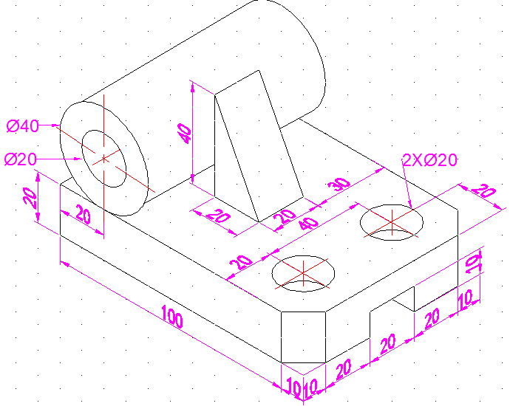

4.12 Solid Exercise 10
Construct the solid model shown below.
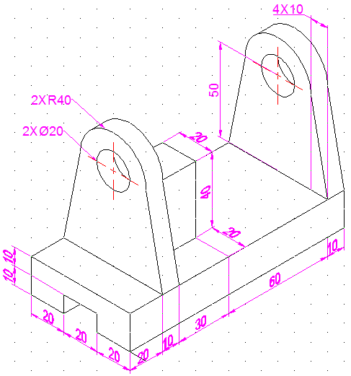

4.13 Solid Exercise 11
Construct the solid model shown below.
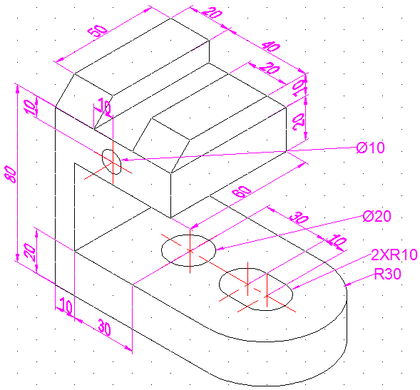

4.14 Solid Exercise 12
Construct the solid model shown below.
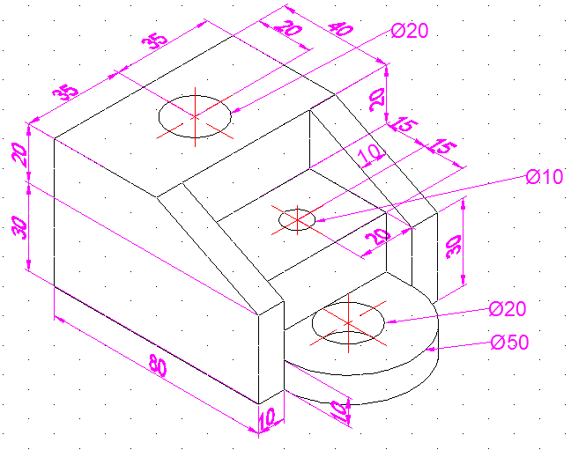

4.15 Solid Exercise 13
Construct the solid model shown below.
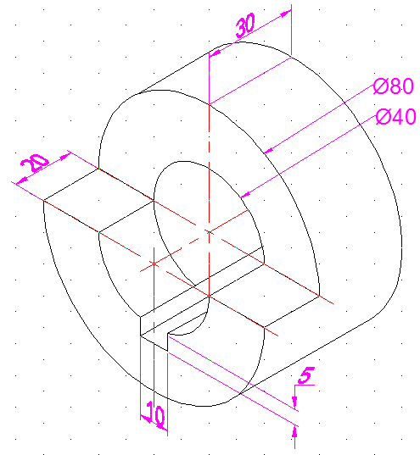

SELECTEDPROBLEMS

4.1 Linear/Circular Sweep
Create wireframe or solid by sweeping the profiles using a scale of 1:1.
- Sweep linearly 5 units along the +Z axis.
- Sweep linearly along the vector (2,-3,5).
- Sweep 360⁰ about the Y axis.
- Sweep 360⁰ about the X axis.
- Sweep 90⁰ about the +X axis.
- Sweep 270⁰ about the -Y axis.
- Sweep 360⁰ about the Y axis offset 2 units in -X direction.
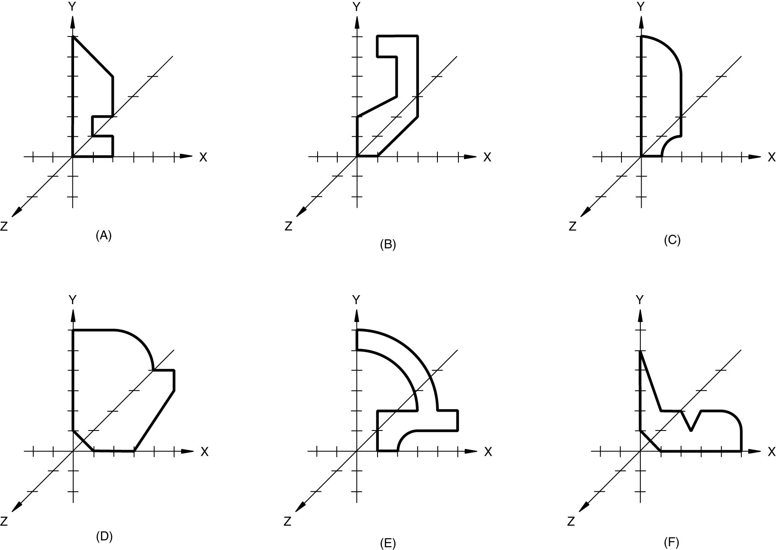

4.2 Problem 4.3
Match the 12 objects swept using diffrents 12 profiles.
.

4.3 Problem 4.7
Create the objects using wireframe or solid modeling techniques in a 1:1 scale.
